iSL is for those who want to grow in leadership effectiveness
Leadership is not for the faint of heart
Leading has always been a challenge, even more so in the 21st century. Leading in the church is the greatest challenge. With the demands on pastors and lay leaders, how are they to grow and be effective? With the demands of ministry, how is a pastor to provide training in leadership? To whom can pastors and lay leaders turn?
Enter: institute for Servant Leadership. iSL exists to serve the church by providing a useable method for equipping leaders.
In the words of an energized couple of middle aged iSL graduates who are passionate and involved in church ministry,

““This is our mission in action: to equip men and women to do effective ministry!”

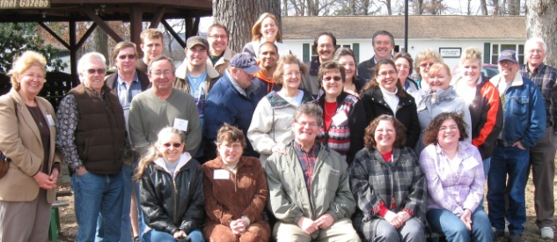

iSL is a catalyst for transformation

It’s not about information,
it is about transformation!!

People and congregations are being transformed, stepping up to make a difference for Christ.
How? Through iSL’s effective blend of
Curriculum that informs and challenges
Practical application that transforms
Presenters who inspire and model
Synergy of learning with others

Leadership
Essentials

Track

Leadership Essentials develops WHO you ARE as a leader. 3 modules (2 days each). The track helps you discover who God created you to be as a leader, develop according to God’s design, improve your effectiveness, and gain tools to serve as a leader in small or large roles.

- Founded on Biblical principles and research based criteria.

- Focused on TRANSFORMATION.

- Designed to provide participants with practical tools to build on for the future.

“iSL has helped me realize, life is about doing as much for God in the time I have here and I really believe iSL has helped me do that. If iSL can’t get you on fire, then you can’t be on fire for anything.” - Jerry Johnston, MI

With the completion of Leadership Essentials, you will be equipped to make a greater difference for God!

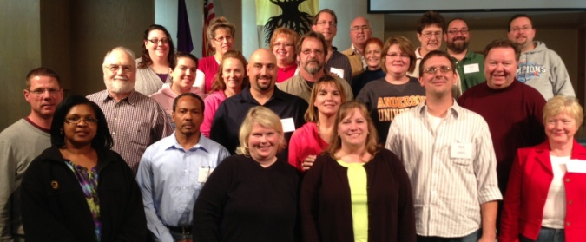

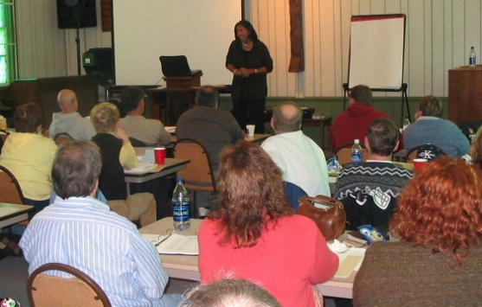
Next Level

Leadership

Track

Many, many good people WANT to help their church move from where they are to where God wants them to be. But they are frustrated. What do they do?

Next Level Leadership will take a person, especially as a member of a team, to the next level of effectiveness for Christ.

Where Leadership Essentials develops who you are, Next Level Leadership develops WHAT you DO as a leader. 3 modules (2 days each).

This is about skills. Ideally, a group of people from a church attend together, to identify (1) current reality, (2) God’s desired future and (3) how to move to that future, turning frustration into fulfillment!

We sent 9 members of our Leadership Team to the iSL Leadership Essentials track. This made a huge impact on the team members and how we functioned as a team. Every church should invest in training their leadership. I highly recommend iSL. - Amy Worline, PA

Church of God
Doctrinal

Track

iSL also offers a Doctrinal Track for those interested in understanding Church of God doctrinal distinctives.
The Doctrinal Track is not a comprehen-sive study of Biblical doctrine, but rather highlights the unique blend of doctrinal distinctives of the Church of God. This track is of special interest for those who desire to be credentialed in the Church of God as it guides a participant in writing a Doctrinal Statement.

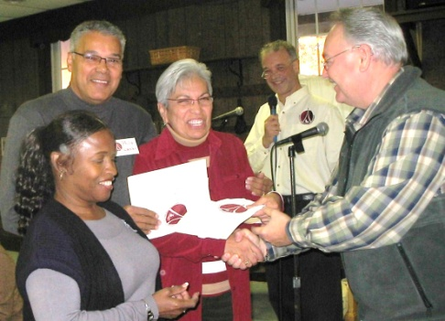

I benefited so much that I sent some of the leaders from the church. Each person has grown, leading to confidence and empowering them for service in the church. iSL is a wonderful resource! Chad Troup, PA, pastor

”Do not follow where the path may lead.
Go instead where there is no path
and leave a trail.”
- H.R. McAlindon, (also attributed to Emerson)

Seminar dates
Go to www.iservant.org for details, dates and complete registration information.

New Tracks starting fall of 2015
Clarkston, MI: October 16-17, 2015
#2: March 11-12, 2016; #3:Oct. 7-8, 2016
New Kensington, PA: Nov. 13-14, 2015
#2: April 8-9, 2016; #3:Nov 11-12, 2016

All tracks are three sessions. Each session is two days, (12 hours of instruction).
Registration fees covers the cost of classes, lunches and snacks. Limited scholarships are available. Fees below are for those who register at least two weeks prior to the seminar. Add $25 per person after that.
First person from a church: $139.00
Additional persons: $114.00
Alumni: $ 49.00
Pastors who bring 4 people: FREE

The Institute for Servant Leadership emerged from the hearts of the Church of God district leaders from Indiana, Illinois, Michigan, Ohio, and Pennsylvania. Over the past 23 years the curriculum has changed and evolved, but the focus remains the same: to equip Christians to lead and serve effectively in the local church so that the Great Commission will be fulfilled.

For more information contact Herb Shaffer, Director of iSL:
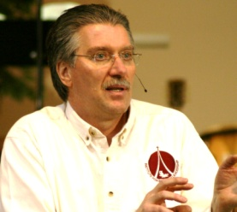
phone:
412-283-0888
email:
herb@iservant.org
web:
www.iservant.org

4/9/2015

God wants to use

YOU

to make a difference!!

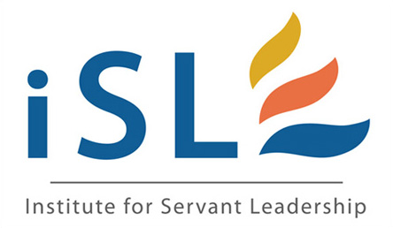

Equipping Christians to be effective servant leaders
in the local church

It’s about transformation, not information

