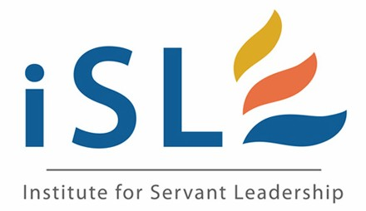
Doctrinal Track

INSTITUTE FOR SERVANT LEADERSHIP

 |  | Hrs | Topic |  | Description
Module One |  | 3 | Understanding the Wesleyan Mind |  | Introduction and Overview to Wesleyan Theology and implications for the Church of God.
 |  |  | Required Reading |  | “Responsible Grace” Randal Maddox, Amazon, $22 or Theology of Holiness and Love, Kenneth E. Jones, Reformation Publishers or Amazon, approx. $15
 |  | 3 | Church of God Heritage |  | Historical overview of the roots and development of the Church of God Reformation Movement.
 |  |  | Required Reading |  | “Theology for Disciples” Gil Stafford, Chapter 15, Warner Press
 |  | 3 | Eight Distinguishing Characteristics of CHOG |  | Identification and description of the eight primary doctrinal distinctive of the Church of God.
 |  |  | Required Reading |  | “This We Believe, This We Proclaim” Earl Martin, Chap 2, Reformation Pub, $6
 |  | 3 | How to Write your  Doctrinal Statement |  | A step by step process to develop a written statement explaining your understanding of Church of God doctrine required by the credentials committee for ordination.
 |  |  | Assignment |  | Write first draft of doctrinal statement.
Module Two |  | 3 | Basis for Biblical Authority and Nature of God |  | An introduction to the understanding of Biblical authority and the foundational nature of God’s essential characteristics.
 |  |  | Required Reading |  | “Theology of Disciples” Gil Stafford, Warner Press
 |  | 3 | The Life of Salvation |  | An overview of human nature, sinfulness, and the saving mission of Jesus Christ that leads to a life of salvation.
 |  |  | Required Reading |  | Theology of Holiness and Love, Kenneth E. Jones
 |  |  |  |  | Reformation Publishers or Amazon, approx. $15
 |  | 4 | Work of the Holy Spirit |  | The work of the Holy Spirit in the salvation, gifting, and sanctification of the believer, and the resulting holiness that produces Christian unity.
 |  |  | Required Reading |  | “Receive the Holy Spirit” Arlo Newell Amazon $5 and up, Reformation Pub $13
 |  | 2 | Developing Your  Doctrinal Statement |  | A workshop that builds on module one to equip learners to prepare, explain and defend their doctrinal statement.
 |  |  | Assignment |  | Write a final draft of doctrinal statement and review with supervising pastor.
Module Three |  | 4 | Practical Functions  of the Church |  | A practical overview of the nature of the church, church leadership and Christian stewardship.
 |  |  | Required Reading |  | “Spiritual Leadership”, revised edition, 2011 by Henry and Richard Blackaby Amazon
 |  | 2 | Aspects of the  Priestly Role |  | Practical training in leading celebrations of ordination, officiating at weddings, funerals, and leading and planning business meetings.
 |  | 4 | The Present and Future Kingdom |  | An overview of the biblical teachings of the Kingdom of God
 |  |  | Required Reading |  | “The Church of God as Revealed in Scripture” Arlo Newell Reformation Pub $5,
 |  | 2 | Review of  Doctrinal Statement |  | Opportunity for participants to interact with presenters to clarify, amplify and/or revise troubling aspects of the doctrinal statement.
 |  |  | Assignment |  | Submit doctrinal statement to Credentials Committee.  Develop a plan for improvement in personal stewardship of heart, mind, soul and body.  Develop a wedding service, a funeral service, a communion meditation and create a worship service.
revised February, 2012

